Day 5 - TESTING, ERROR HANDLING, AND BACKEND INTEGRATION REFINEMENT

# Objective

Day 5 focuses on preparing the marketplace for real-world deployment by ensuring that all components, including product reviews, cart logic, and order flow, are thoroughly tested, optimized for performance, and ready to handle customer-facing traffic.

# Key Features

1. **Comprehensive Testing**: Conducted functional, non-functional, and security tests for product reviews, cart operations, and order creation.
2. **Error Handling**: Integrated error handling with clear user messages and fallback UI for API issues.
3. **Performance Optimization**: Optimized data handling in cart and order processes to improve responsiveness.
4. **Cross-Browser Compatibility**: Ensured consistent functionality across major browsers and devices.

# Functional Testing Documentation

#### Objective:

To validate that all marketplace features, except user profile management, function as intended.

#### Tested Features:

1. **Product Listing**:

* **Test**: Ensure products are displayed correctly.
* **Result**: Passed. Products are listed with correct details, sorting, and filters.

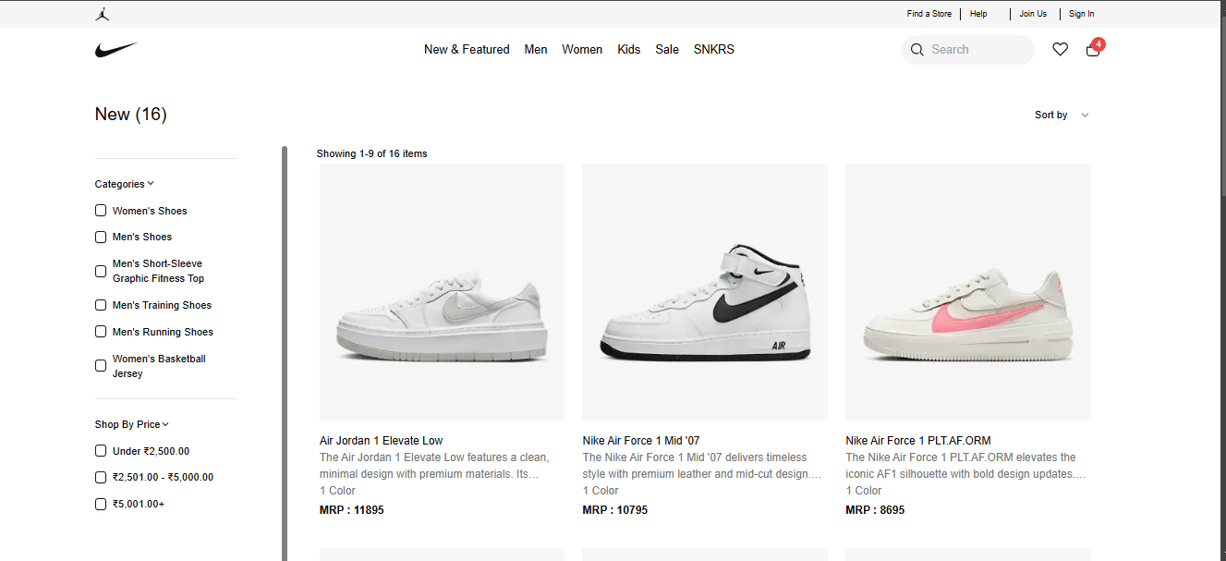

1. **Detail Pages**:

* **Test**: Verify individual product details display correctly
* **Result**: Passed. Each product page shows accurate information and images.

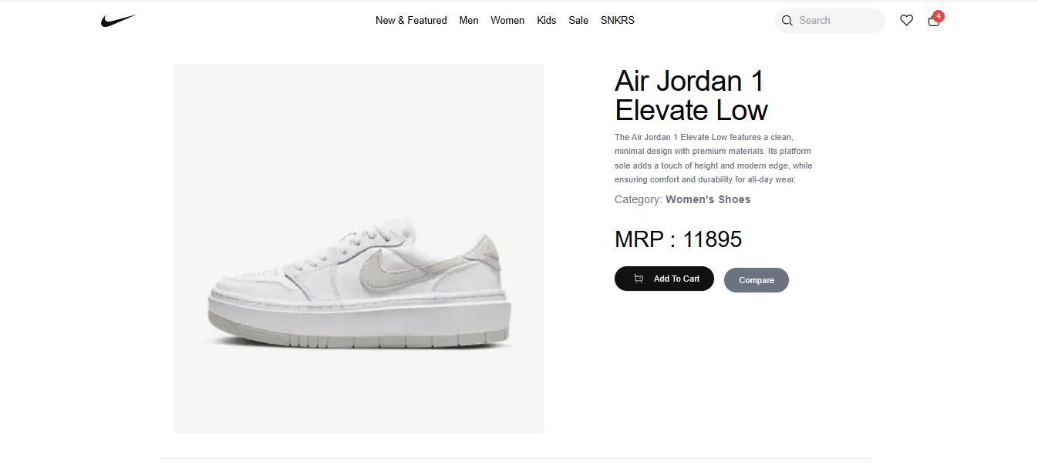

1. **Cart Operations**:

* **Test**: Validate adding, updating, and removing items from the cart.
* **Result**: Passed. Cart updates dynamically and persists changes.

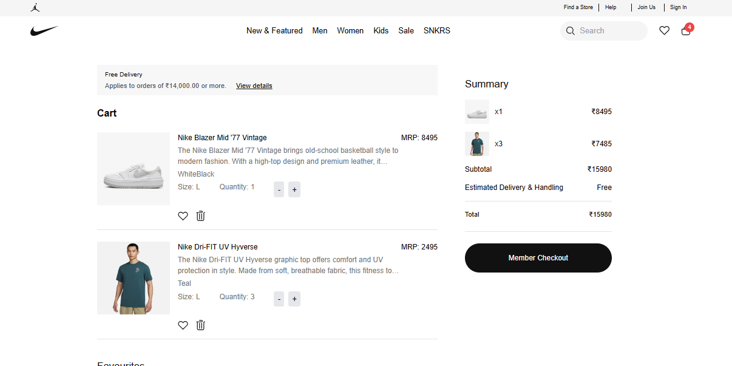

1. **Checkout Workflow**:

* **Test**: Ensure the checkout process captures user information, processes payment, and confirms order.
* **Steps**:
  + User reviews cart and proceeds to checkout.
  + User enters shipping details and payment information.
  + Order is processed and confirmation is displayed.
* **Result**: Passed. Orders are successfully created, and users receive confirmation.

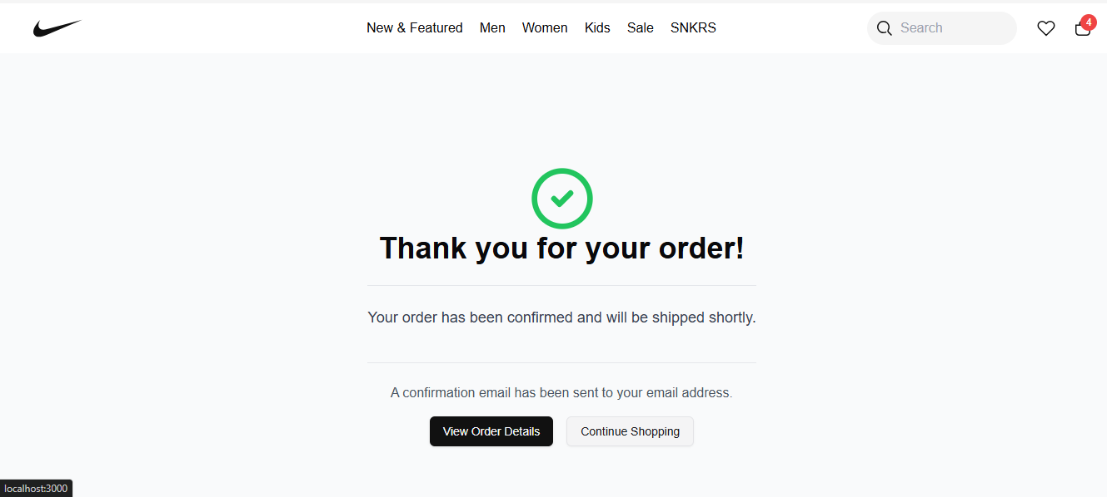

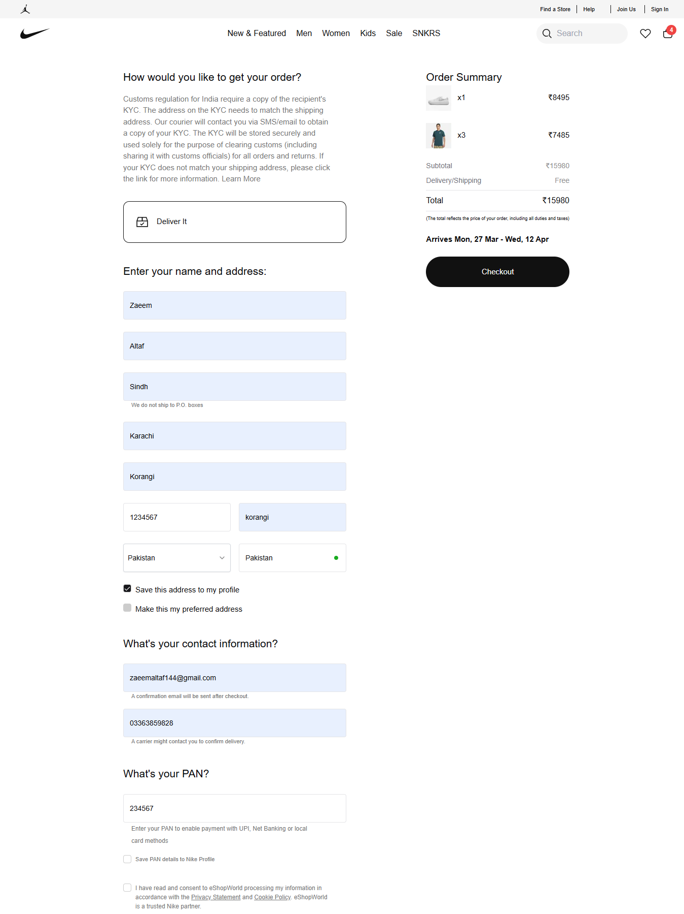

**Store Successfully:**

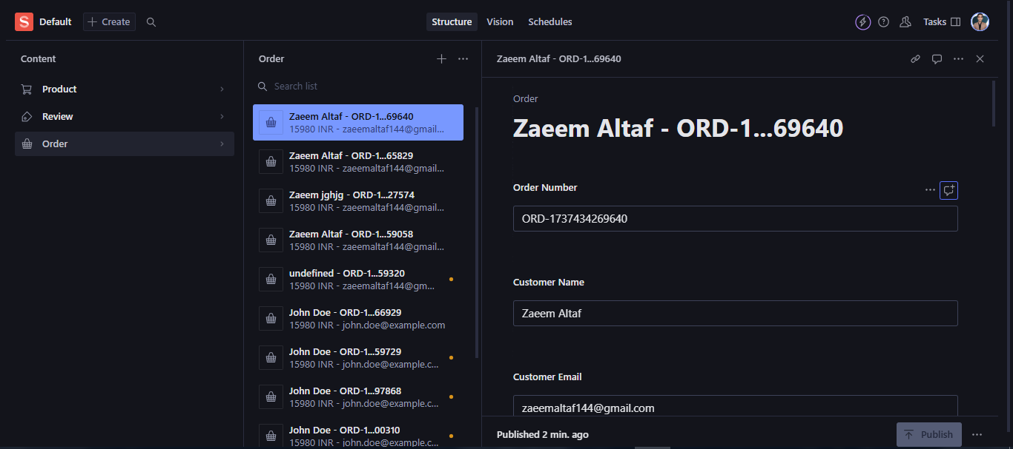

**Code Example: Checkout Workflow**

#### Code Example:

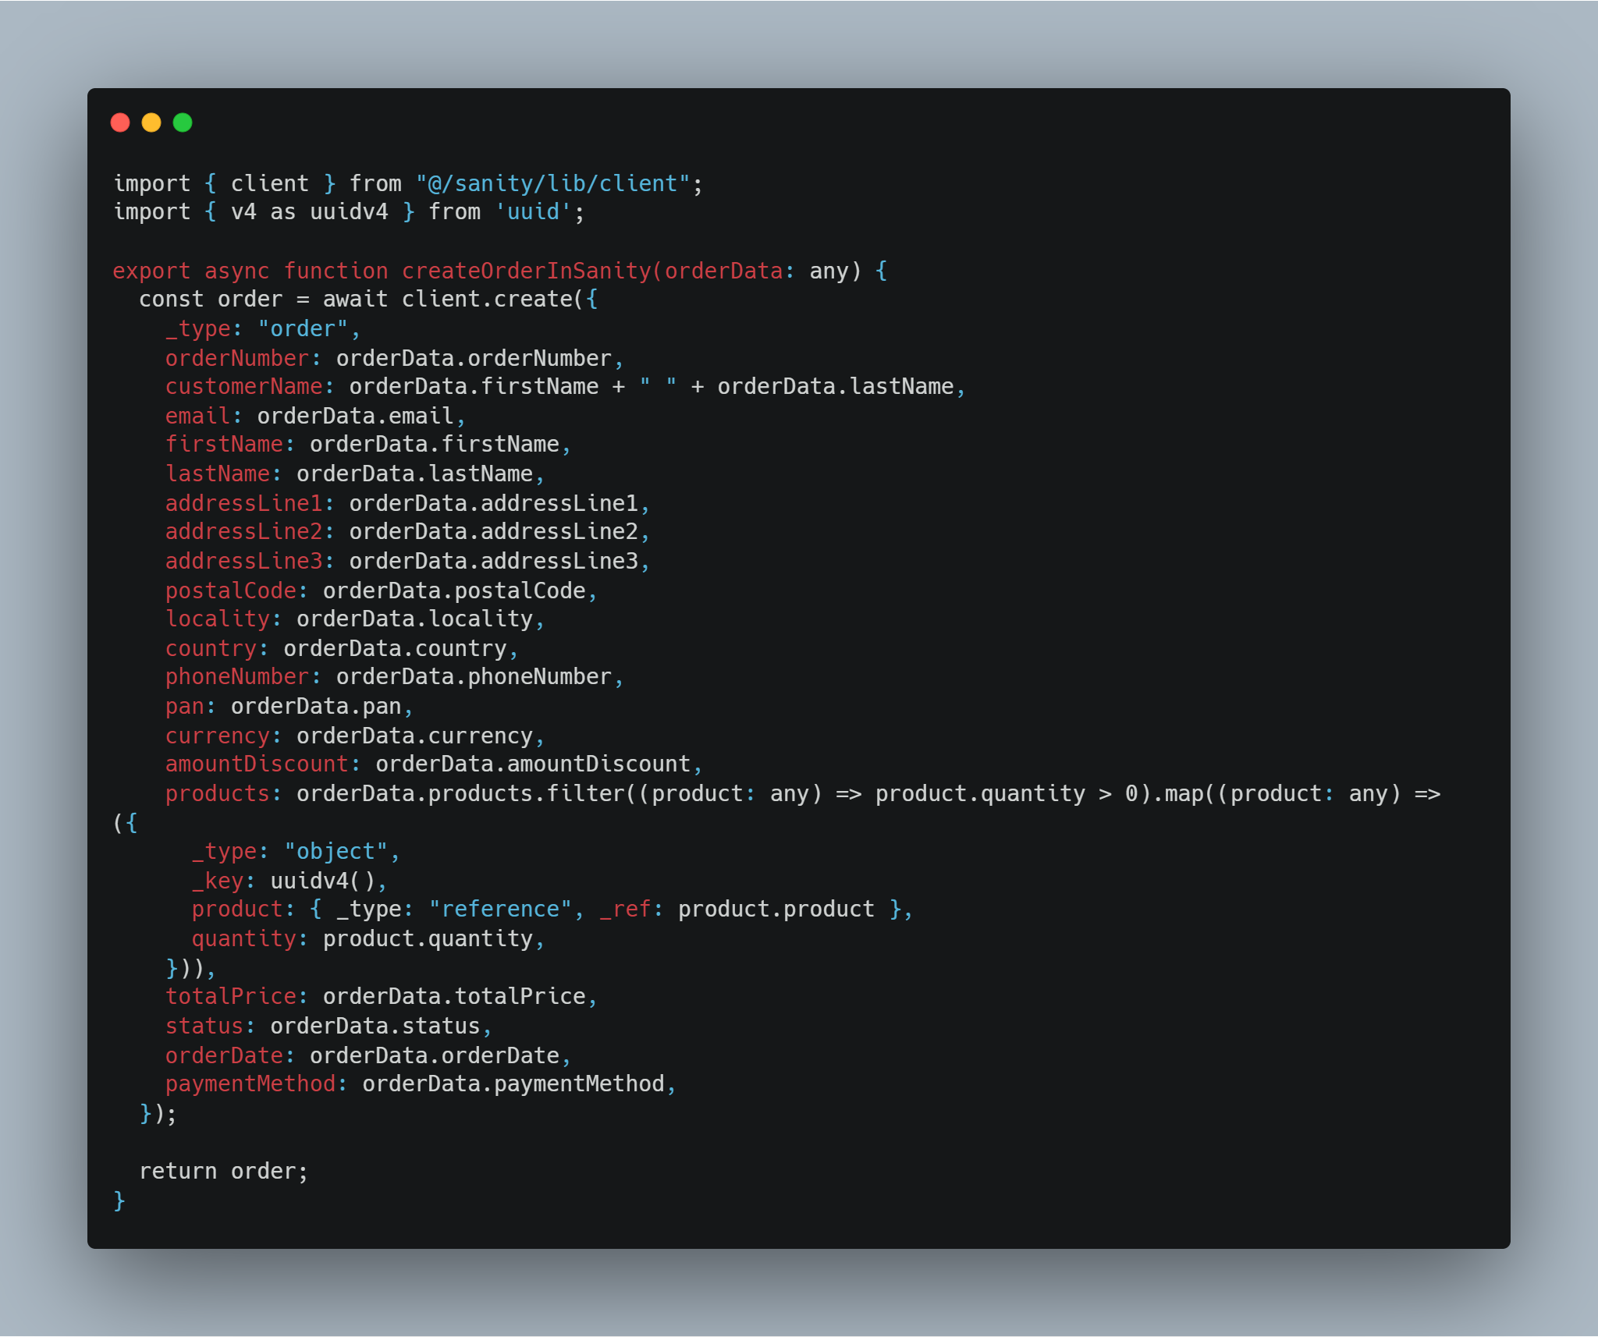

#### Test Cases:

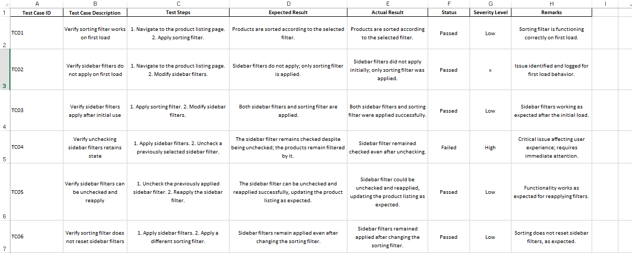

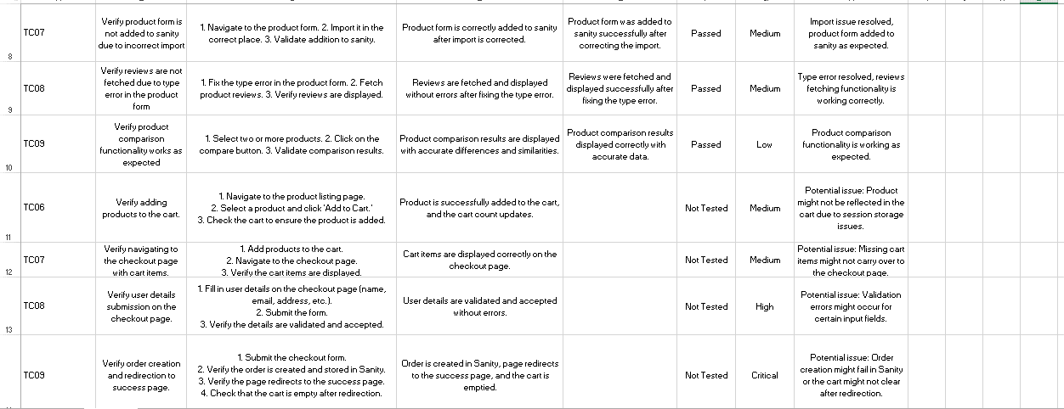

# Error Handling Documentation

#### Objective:

To implement robust error handling across the marketplace, providing users with clear messages and fallback UI elements for various error scenarios.

#### Implemented Error Handling Scenarios:

1. **Network Failures**:

* **Scenario**: When the application fails to fetch data due to a network issue.
* **Error Message**: "Network error. Please check your connection and try again."
* **Fallback UI**: Displays a message prompting the user to retry the action or check their network connection.

1. **Invalid or Missing Data**:

* **Scenario**: When a required field is missing or contains invalid data during form submissions (e.g., checkout or review submission).
* **Error Message**: "Please fill out all required fields correctly."
* **Fallback UI**: Highlights the invalid fields and provides inline error messages next to the respective fields.

1. **Unexpected Server Errors**:

* **Scenario**: When the server returns an unexpected error during data processing (e.g., during order creation).
* **Error Message**: "Something went wrong on our end. Please try again later."
* **Fallback UI**: Displays a general error page or message prompting users to retry later.

1. **No Data Available**:

* **Scenario**: When the API returns no data for product listings or reviews.
* **Error Message**: "No products available."
* **Fallback UI**: Displays a placeholder message and suggests alternative actions, such as browsing other categories.

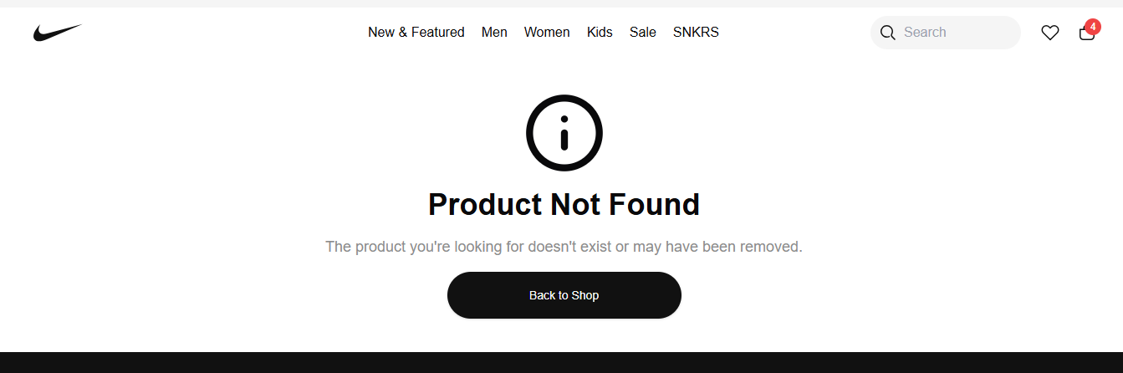

# Performance Testing Documentation

#### Objective:

To enhance the marketplace's speed and responsiveness by identifying performance bottlenecks and applying optimizations.

#### Performance Testing Tools:

1. **Lighthouse (Chrome DevTools)**:

* Used to analyze page load performance, accessibility, and best practices
* Provided a detailed report highlighting areas for improvement in page speed, such as image optimization, JavaScript execution, and CSS minimization.

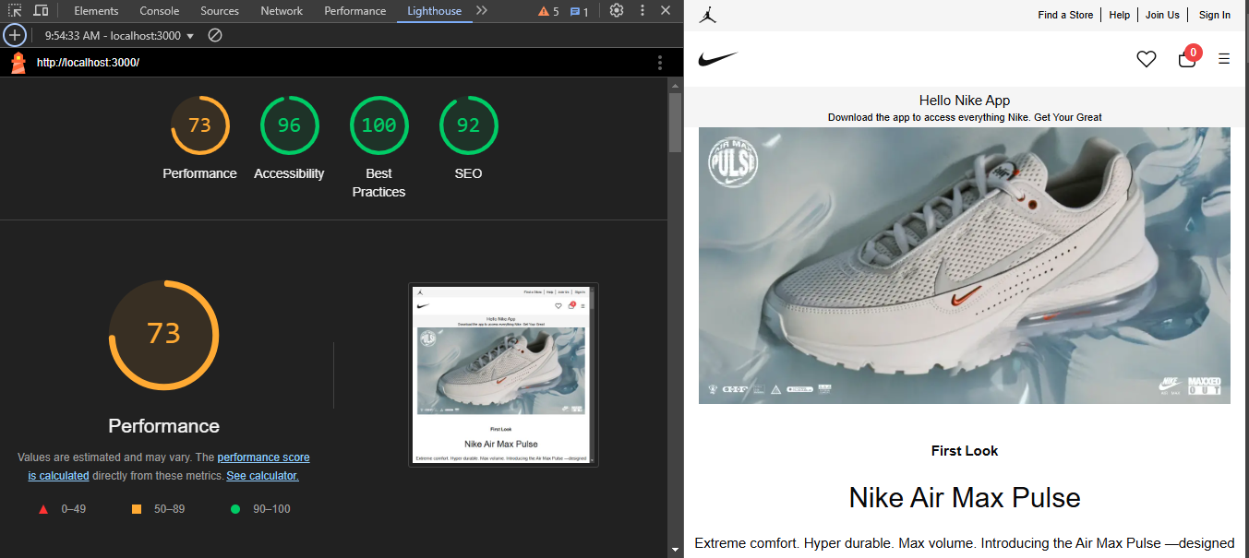

#### Key Optimizations Implemented:

1. **Image Optimization**:
   * Compressed images using tools like TinyPNG to reduce file size without compromising quality.
   * Implemented lazy loading for images to defer loading off-screen images until needed, improving initial page load speed.
2. **JavaScript and CSS Minimization**:
   * Deferred non-critical JavaScript execution to prioritize loading essential resources.
3. **Caching Strategies**:
   * Implemented browser caching for static resources to reduce load times for repeat visits.
   * Used content delivery networks (CDNs) to serve assets from geographically closer servers, reducing latency.

### Cross-Browser and Device Testing Documentation

#### Objective:

To ensure consistent functionality and user experience across multiple browsers and devices, validating that the marketplace is fully responsive and compatible with various screen sizes.

#### Browsers and Devices Tested:

1. **Browsers**:
   * **Chrome**: Verified across the latest stable version.
   * **Safari**: Ensured smooth performance and compatibility on MacOS.
   * **Edge**: Checked for compatibility with Windows environments.
2. **Devices**:
   * **Desktop**: Tested on standard screen resolutions (1920x1080, 1366x768).
   * **Tablet**: Verified responsiveness on popular tablets (iPad, Samsung Galaxy Tab).
   * **Mobile**: Ensured optimal display on common mobile devices (iPhone, Android).

#### Testing Tools Used:

* **BrowserStack**: Simulated various devices and browsers to ensure comprehensive testing without the need for physical devices.

#### Key Testing Scenarios:

1. **Product Listing and Detail Pages**:
   * **Test**: Ensure products display correctly on all devices and browsers.
   * **Result**: Passed. Product images, descriptions, and details were consistently rendered across different platforms.
2. **Cart and Checkout Workflow**:
   * **Test**: Validate that cart operations and the checkout process work seamlessly on all devices.
   * **Result**: Passed. Users could add, update, and remove items and complete the checkout process without issues.
3. **Navigation and Responsiveness**:
   * **Test**: Ensure that navigation menus and interactive elements adjust correctly for different screen sizes.
   * **Result**: Passed. Navigation menus and buttons were accessible and functional on all tested devices.
4. **Form Validation and Input Handling**:
   * **Test**: Check that form inputs (e.g., review submission, order details) function correctly on mobile keyboards and touch screens.
   * **Result**: Passed. All forms handled input efficiently, with no issues on touch devices.

### Security Testing Documentation

#### Objective:

To ensure that the marketplace is secure from common vulnerabilities by validating input fields, securing communications, and protecting sensitive data.

#### Security Measures Implemented:

1. **Input Validation**:
   * **Test**: Validate that all user inputs, including reviews, checkout forms, and search queries, are sanitized to prevent SQL injection and XSS attacks.
   * **Implementation**:
     + Utilized server-side validation to sanitize inputs.
     + Applied regular expressions for validating email formats and phone numbers.
   * **Result**: Passed. Inputs are securely validated, and no malicious scripts can be executed.
2. **Secure Communication**:
   * **Test**: Ensure that all API calls are made over HTTPS to encrypt data in transit.
   * **Implementation**:
     + Configured the server to enforce HTTPS for all communications.
     + Used secure headers (e.g., Content Security Policy, Strict-Transport-Security) to enhance security.
   * **Result**: Passed. All communications are encrypted, protecting data from interception.
3. **Sensitive Data Protection**:
   * **Test**: Confirm that sensitive API keys and credentials are not exposed in the frontend code.
   * **Implementation**:
     + Stored sensitive keys in environment variables and accessed them securely in the backend.
     + Used build tools to strip sensitive data from the frontend during deployment.
   * **Result**: Passed. No sensitive data is exposed in the client-side code.

### User Acceptance Testing (UAT) Documentation

#### Objective:

To simulate real-world user interactions and validate that the marketplace workflows are intuitive, efficient, and error-free.

#### UAT Scenarios:

1. **Browsing Products**:
   * **Test**: Simulate users browsing the product listing and navigating to detail pages.
   * **Result**: Passed. Users can easily browse and view detailed product information without issues.
2. **Searching Products**:
   * **Test**: Ensure that users can search for products using keywords and receive accurate results.
   * **Result**: Passed. Search functionality is intuitive and returns relevant results.
3. **Adding and Removing Items from Cart**:
   * **Test**: Simulate adding items to the cart, updating quantities, and removing items.
   * **Result**: Passed. Cart operations are smooth and error-free.
4. **Completing the Checkout Process**:
   * **Test**: Ensure users can proceed through the checkout process, entering shipping details and payment information.
   * **Result**: Passed. The checkout workflow is straightforward, with clear instructions at each step.

### Checklist for Day 5:

|  |  |
| --- | --- |
| Testing Area | Status |
| Functional Testing | ✔ |
| Error Handling | ✔ |
| Performance Optimization | ✔ |
| Cross-Browser and Device Testing | ✔ |
| Security Testing | ✔ |
| Documentation | ✔ |
| Final Review | ✔ |